FOB Ningbo: 95USD
1. Suitcase Item No.:9008B
2. Material: PC+ABS
3.Caster: spinner
4.Style: luxury looking
5.Size: 20''24''28''
Handle Height |  | 80cm
Wheel |  | 6"
Front width |  | 45cm
Wheelbase |  | 50cm
Luggage box |  | 60x40X25cm
N.W |  | 8kg
G.W |  | 9kg
Packing size |  | 61X41X26CM
20GP/550pcs
40HP/1200PCS
MOQ100PCS
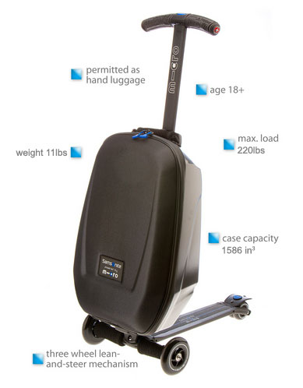
- Quality Design Case
- Permitted as hand luggage
- Weight 11lbs
- Three wheel lean-and-steer mechanism
- Max. load 220lbs
- Case capacity 1586 in³
- Age 18+
Bored with dragging your hand luggage and yourself through the airport? Trolley luggage is designed for the frequent flyer who needs to move quickly and effortlessly. Instead of pulling your luggage, how about riding on it to the gate? Trolley luggage is a specially designed luggage case with a built-in scooter allowing you to move quickly and easily. When folded, it fits in standard size overhead bins. When you are done scooting, the scooter folds up turning it into conventional wheeled luggage. The handlebar also retracts for carrying or placing in the overhead bin.
In addition to two luggage compartments, Trolley Luggage has a separate compartment for you PC and place for business cards, folders etc that can be easily accessed without disturbing the rest of your luggage.

